

Media Contact:
Natalie P. Mikolich
natalie@npmpr.com
561.414.4047

FOR IMMEDIATE RELEASE March 7, 2011

Dog-E-Glow Launches New Line of Stylish, Safe LED Collars and Leashes
Technology Meets Fashion to Offer New Illuminated Style Designs

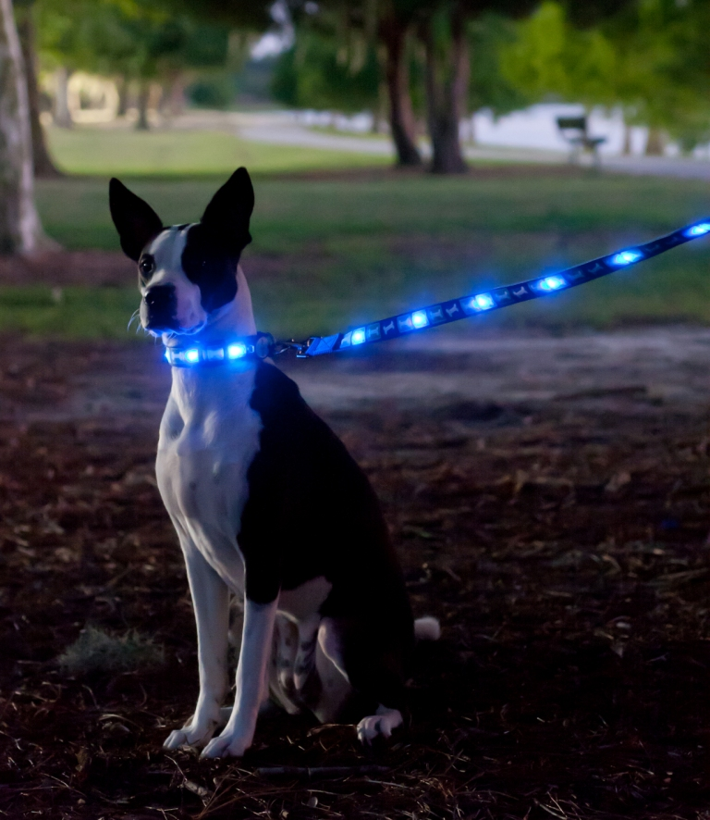
March 7, 2011, Ft. Lauderdale – Dog-E-Glow LLC (http://www.dogeglow.com/), the makers of the Dog-E-Glow LED collar and Dog-E-Glow LED leash, announced today the launch of their new line of LED lighted dog collars and leashes as the latest necessity and accessory in canine style and safety. With collars and leashes illuminating in their entire length for maximum visibility at night, they can be seen up to 1,000 feet away providing the ultimate safety in night time walks.

Coming in medium and large collar sizes, there are 12 stylish illuminated designs available for purchase to match any dog’s personality from girlie to sporty, or rough-and-tough. All of the Dog-E-Glow collars and leashes are safe and are made of high quality nylon sewn around several highly-efficient (100,000 hour) LED bulbs. The lights are only visible when turned on, either in a steady glow or flashing mode and contain batteries that are easily replaceable after 150 hours of LED use.

With all of the Dog-E-Glow collars and leashes being lightweight, highly durable and fully weather-resistant, they are helpful for keeping an eye on your canine companion when traveling, enjoying outdoor activities or exercising with your dog on bike riding adventures or jogging paths in addition to everyday walks.

“Our company firmly believes in the numerous benefits of the Dog-E-Glow™ brand, from both the safety and fashion perspective,” said Greg Brauser, Dog-E-Glow CEO. “As a company, we continue to improve our product technology and design to keep dogs everywhere visible and looking good for years to come!”

Dog-E-Glow was founded by dog and outdoor lovers who above all wanted to keep their pets and others safe while looking their very best. The founders of Dog-E-Glow have a combined 50+ years of manufacturing and distribution experience in the pet product industry launching several new and innovative pet products over the years that visibly distinguish themselves. In the near future, Dog-E-Glow plans to expand their current line in new design styles and sizes for all dogs.

For additional information on Dog-E-Glow, please visit http://www.dogeglow.com/ or call (954) 239-1833.

###

About Dog-E-Glow
Dog-E-Glow LLC is the world’s leading innovator in the LED dog collar and leash market. The company manufactures and distributes collars and leashes with LED technology, allowing you to easily spot your dog from a distance when it is dark outside. Dog-E-Glow products are truly one of a kind, combining high quality materials with catchy, fun designs and the functionality of bright LED lights. For more information on Dog-E-Glow, visit: www.dogeglow.com

